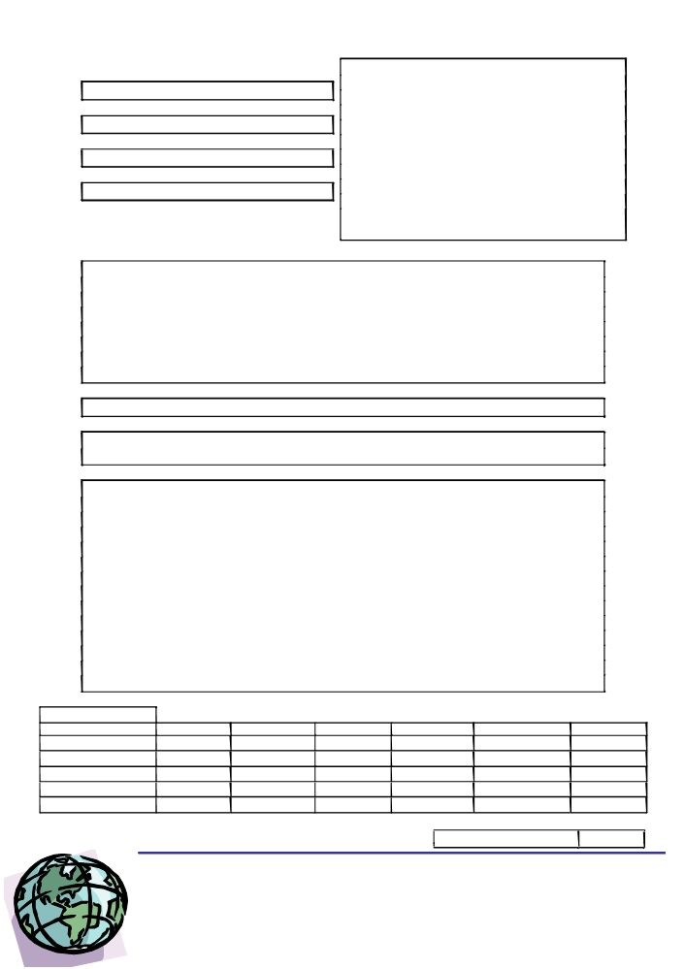
Freelance Interpreters/Translators Registration Form

Mr/Ms/Mrs/Miss
SURNAME:

FORENAMES:

NATIONALITY:

DATE OF BIRTH:

POSTAL ADDRESS:

Post Code:

How did you hear of us?

Mother Tongue:

Main Interpreting/ Translation Combinations in order of fluency:

Subject Specialisms:

Services offered (delete as appropriate): Translation / Interpreting

TEL No:

MOBILE No.:

FAX No.:

E-mail:

How long have you been employed as a qualified interpreter/translator?

QUALIFICATIONS (please list institutions and dates):

Interpreting Qualifications

Translation Qualifications

Member of Recognised Institutions

RATES:

Translation Proofreading Interpreting
Per 1000 words
Minimum charge
per hour
per half day
per day

TRANSWORLD
Breaking down Communication Barrier
Consecutive Simultaneous Telephone

Please initial here
273 Chorley New Road
Bolton, Lancs
BL1 4PH
Tel : 0845 862 2813
Fax : 0845 862 2814
email : info@transworld-uk.com

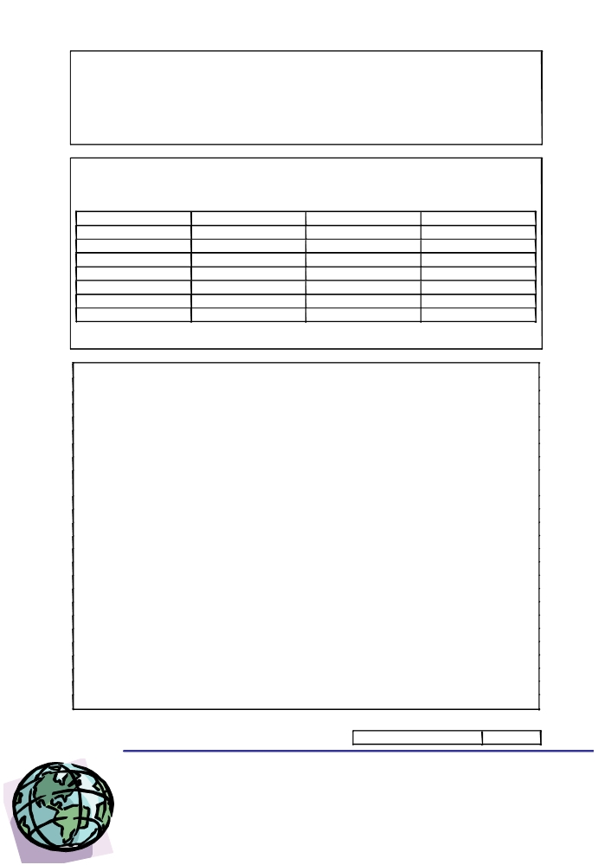
Freelance Interpreters/Translators Registration Form
TRANSLATION EXPERIENCE

INTERPRETING EXPERIENCE (Simultaneous /Consecutive/Telephone - please circle)

AVAILABILITY

Please indicate your availability for interpreting and/or translation assignments.

MORNING AFTERNOON EVENING
MONDAY
TUESDAY
WEDNESDAY
THURSDAY
FRIDAY
SATURDAY
SUNDAY

COMPUTER APPLICATIONS / EQUIPMENT (please list all hardware and relevant software you have at home, e.g. Windows XP, Inpage, Excel, Quark, Trados).

REFEREES (x2)
Please provide the following details for two past employers who have used your services as interpreter/translator. If you do not have two past employers, please provide an academic reference. Copies of existing references may be provided if accompanied with contact details

Name:
Job title:
Email address:
Postal address:
Telephone number:

Name:
Job title:
Email address:
Postal address:
Telephone number:

Please initial here

TRANSWORLD 271 Chorley New Road
Breaking down Communication Barrier Bolton, Lancs
BL1 4PH
Tel : 0845 862 2813
Fax : 0845 862 2814
email : info@transworld-uk.com

Freelance Interpreters/Translators Registration Form
ADDITIONAL INFORMATION
Please provide any additional relevant information about yourself.

Please initial here

TRANSWORLD 271 Chorley New Road
Breaking down Communication Barrier Bolton, Lancs
BL1 4PH
Tel : 0845 862 2813
Fax : 0845 862 2814 info@transworld-uk.com

